Global Healthcare Summit | 18- 20 November 2021
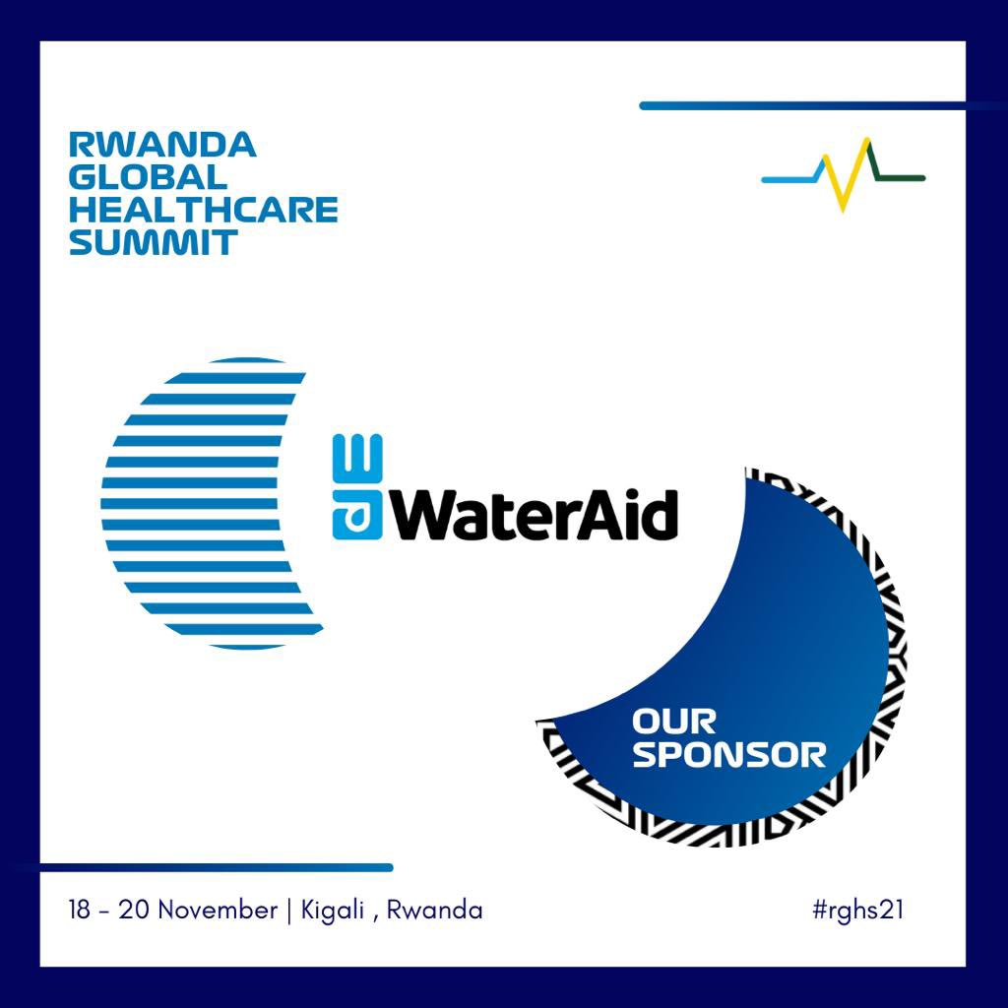
The 2021 Global Healthcare Summit will take place from Thursday, 18 November, through Saturday, 20 November 2021. The summit, being organized under the auspices of the Rwandan Ministry of Health and facilitated by Be Still Investments, aims to spark a global conversation on the healthcare of today, the pandemic preparedness and to raise awareness on health issues and multi-sector dimensions as it relates to people’s lives in 2021 and beyond. The summit will feature a range of pertinent topics that seek to empower and enable stakeholders to address the Sustainable Development Goal (SDG) 3: Good Health and Wellbeing.
At the Global Healthcare Summit, WaterAid will advocate for better integration of water, sanitation, and hygiene (WASH) into the health sector. At the heart of the Summit, WaterAid will host a side event, an exhibition and introduce the Hygiene for Health (H4H) campaign to a new audience. The Summit coincides with WaterAid’s commemoration of World Toilet Day on 19 November 2021.
The COVID-19 pandemic illustrates the vital importance of continued investment in comprehensive disease prevention measures, which are critical to strengthening preparedness and response to other diseases including cholera and neglected tropical diseases, as well as emerging health threats such as antimicrobial resistance.
Building health systems resilience and strengthening pandemic preparedness and response is unachievable without adequately addressing the most fundamental pillars of public health which is a comprehensive water, sanitation, and hygiene (WASH) services.
The Rwanda Global Healthcare Summit 2021 will be a hybrid event and is expecting over 1,200 delegates consisting of Health Ministers, Representatives of African Governments, development partners including donors and other international agencies, high profiled health experts and hospitals decision makers, health procurement managers, pharmaceutical and bio medical engineers, among others.
Check back regularly for updates.
You can find more information at Rwanda Global HealthCare Summit – Be Still Investment (bestillinvestments.com)
For more information on WaterAid’s event at the Summit, contact:
Elizabeth Mwambulukutu, Regional Communications Manager, WaterAid East Africa, WaterAid
elizabethmwambulukutu@wateraid.org
Dedo Mate-Kodjo, Pan Africa Programme Manager, WaterAid
DedoMateKodjo@wateraid.org

