47-49 Durham Street, London, SE11 5JD

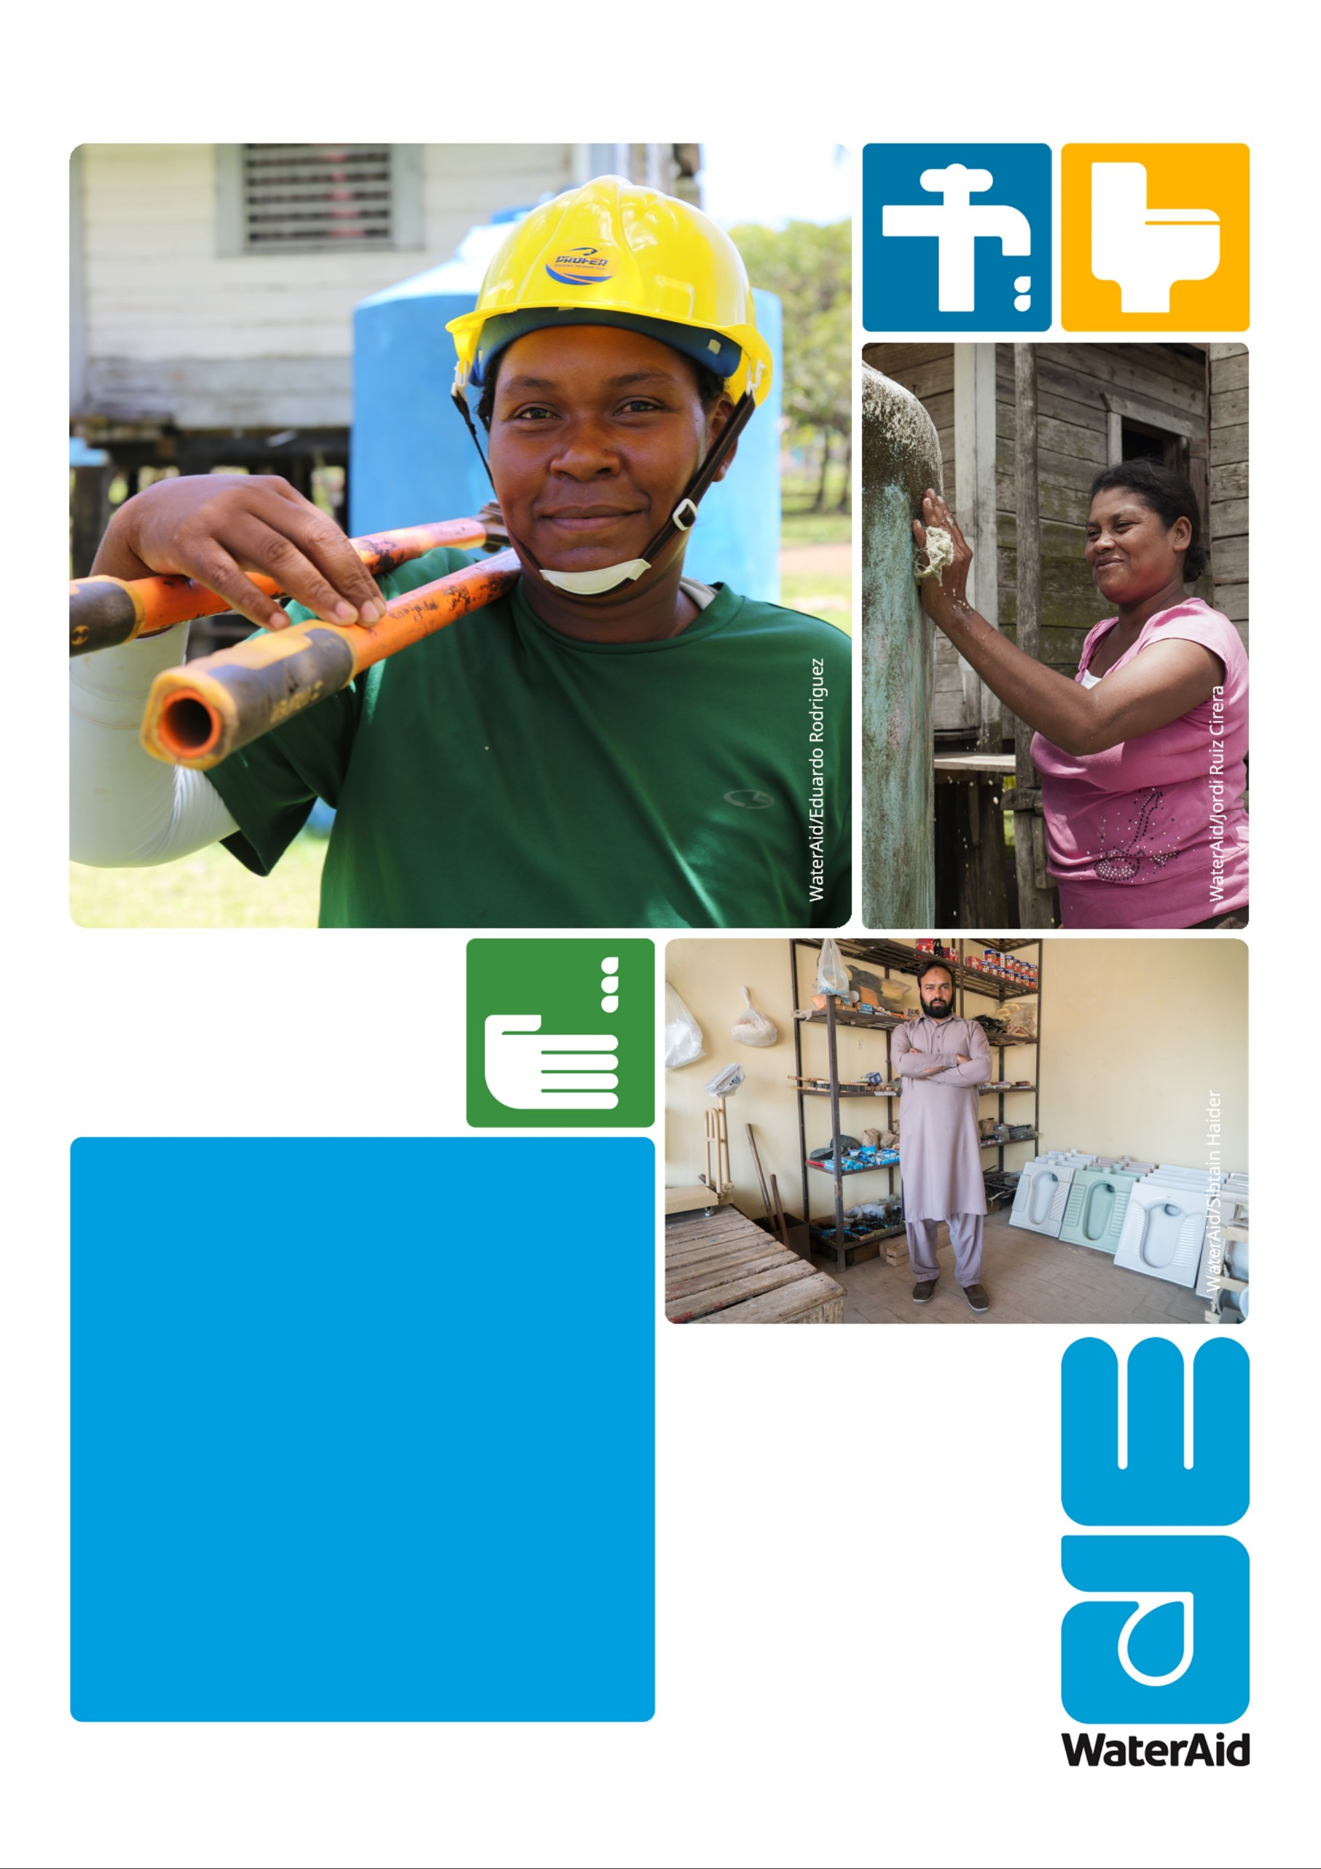
Role description
Fundraising and Administration Volunteer

Who we are

Since we started in 1981, we’ve remained resolutely focused on tackling these three essentials that transform people’s lives.

Without all three, people can’t live dignified, healthy lives. With all three, they can unlock their potential, break free from poverty, and change their lives for good. Children grow up healthy and strong, women and men get to earn a living, whole communities start to thrive. It sounds normal and it should be.

We’re committed to changing normal forever—are you?
Join WaterAid as a Fundraising and Events Volunteer to work in one of the UK’s Best Workplaces™ acknowledged by 2018’s Great Place to Work®.

About the role

Fundraising and Administration Volunteer
Place of work: | 47- 49 Durham Street, London SE11 5JD
Salary: | Unpaid voluntary role – reasonable travel expense from within London zones 1-6 and £6 towards lunch
Contract type: | 21 hours (3 days) per week for 3 months (with possibility of extension)
Reports to: | Hannah McCausland – Trust Officer
Start date: | As soon as possible

Team description
You will be part of the Philanthropy & Trusts team, where you will support us in raising c£4 million per year. We are a team of ambitious professionals specialising in fundraising from high net worth individuals and trusts. We provide high quality donor stewardship and grant management, prospect research and the development of bespoke communications and events.

Job purpose
Your administrative support and valued contributions will be vital to our work, enabling us to maximise our time and help WaterAid reach everyone, everywhere with clean water, sanitation and hygiene by 2030. The role will include, but is not limited to:

- Providing support to account managers for supporter meetings, including preparing information and managing logistics
- Writing compelling and high quality supporter communications, including project progress reports and event invitations
- Producing creative communications for supporters
- Supporting the team with general administration, including managing emails and maintaining accurate records on our CRM database
- Supporting on the delivery of key events through mailings, logistics and pre-event planning
- Supporting the team on events preparations

If you are enthusiastic and looking to build your skills and experience in international development, then this could be the role for you. We are committed to supporting your personal development goals and will be happy to discuss the opportunities at interview.

Person specification

Essential skills
- Working style that reflects WaterAid’s values of Respect, Accountability, Courage, Collaboration, Integrity and Innovation.
- Commitment to WaterAid’s ethos and work
- Passion for international development
- Strong communication skills, creativity and attention to detail
- Ability to self-motivate and able to work independently
- Experience in using Microsoft Office
- Enthusiastic individual with a flexible, ‘can-do’ attitude
- Commitment to confidentiality and an interest in learning about GDPR compliance

Desirable skills
- Experience in administrative or fundraising roles
- Experience working with trusts or philanthropists
- Experience working with databases

