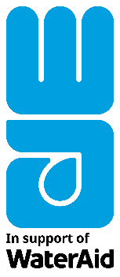
PRESS RELEASE
For Immediate Release
[Insert date]
[Name of church] organises / raises [insert activity or money raised] to help WaterAid give the gift of clean water this Christmas
UK government to match donations to Future on Tap Appeal before 4 February 2021 up to £2 million to help transform lives in Ethiopia
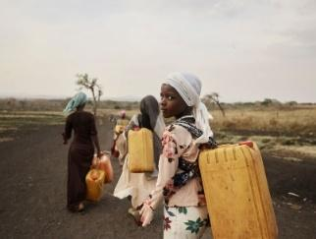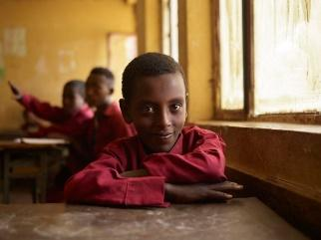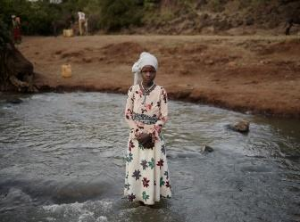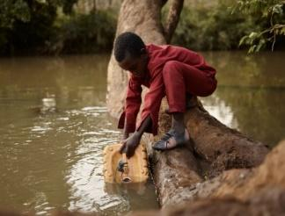
Download images here
The congregation of [name of church] is [insert activity and / or money raised] to support WaterAid’s Christmas appeal, Future on Tap, so people in the world’s poorest places can unearth a clean, reliable source of water and build a brighter future.
This year, despite the restrictions faced by everyone across the UK, [name of church] has met virtually to use WaterAid’s online resources, which include fundraising ideas and youth group activities.

WaterAid aims to raise £3 million to help transform thousands of lives in Ethiopia and across the world. Donations made before 4 February 2021 will be matched by the UK government, up to £2 million, doubling the impact in communities across Ethiopia.

[name of spokesperson] of [name of church] said:
“There is no doubt that this has been a difficult and challenging year for many families in the UK and globally. That is why I am so proud that the congregation of [name of church] has still come together virtually to help make a real difference this Christmas by [insert activity] and raising money for WaterAid’s Future on Tap Appeal.
“Clean water and soap are vital for good health, helping people protect themselves against the spread of infectious diseases, like Covid-19. Yet one in ten people have no clean water close to home. By supporting WaterAid, we hope our congregation will be able to help give the gift of clean water so communities stay healthy and build a better future.”

Globally, 785 million people don’t have clean water. In Ethiopia, nearly two-thirds of people live without this basic human right, including those in Frat, where families spend hours each day collecting dirty water from a river at the bottom of a hill.

The community is diverse but not divided with Christians and Muslims living side by side and supporting each other to stay strong in the face of adversity. However, our changing climate is making life even harder, with unpredictable weather threatening crops – their only source of income.

By supporting WaterAid, [name of church] will help transform the lives of people like 12-year-old Ansha from Frat who spends hours every day fetching dirty water when she could be studying, helping fulfil her potential.

At school, students are often thirsty as there’s no water to drink and nowhere to wash their hands, leaving them vulnerable to disease.

Ansha said:

“We go to collect water in the morning and so sometimes I’m late to school. If I miss lessons, I have to catch up from friends, which is difficult. It’s hard work collecting water; we usually help each other to pick up the jerry cans as they’re very heavy. If I didn’t have to spend time collecting water, I’d have more time to play with my friends and do my homework.”

In partnership with the local community, WaterAid will dig a borehole to reach clean spring water, which will then be pumped uphill using renewable solar energy to a new 75,000-litre reservoir. By raising £140, churches could help to pay to install a solar panel, while £620 could help to build a handwashing point at a school.

Match funding from the UK government will be used to bring sustainable water, toilet and hygiene facilities to communities in Berbere, which like Frat, is one of the poorest and most climate-vulnerable areas in Ethiopia. The project will include constructing flood-resistant community water points and accessible water and sanitation facilities in schools and health centres, as well as training communities to manage the facilities.

By supporting Future on Tap, church congregations like [insert name] can make sure communities like Frat and Berbere can rely on clean water, today and every day.

Marcus Missen, Director of Fundraising and Communications at WaterAid said:

“Christmas will be very different this year but we can all still come together, even if just virtually, to help make a difference to people’s lives across the world. Thank you so much to all those churches who have raised vital funds for our Future on Tap campaign, which will help thousands of people in Ethiopia and beyond get access to clean water they can rely on today and every day.

“A reliable source of clean water improves lives and livelihoods, and is the first line of defence against the impact of our changing climate. Clean water means future generations can stay safe and healthy, whatever tomorrow brings. Now more than ever, we need to make clean water, decent toilets and good hygiene a normal part of everyday life for everyone, everywhere.”

To support the appeal, WaterAid has produced a range of free educational and fundraising resources which can be used virtually if churches are closed: a case study, poster, youth group activities, fundraising ideas and a 2021 wall calendar for groups to display.

Find out more at: www.wateraid.org/uk/christmas.

ENDS

Download photos: https://wateraid.assetbank-server.com/assetbank-wateraid/images/assetbox/05c60f9f-322e-4595-b30e-739ad5dea3d2/assetbox.html

For more information, please contact Rosie Stewart, Senior Media Officer, RosieStewart@wateraid.org or Anna France-Williams, Senior Media Officer AnnaFranceWilliams@wateraid.org. Alternatively, call WaterAid’s after-hours press line on +44 (0)7887 521 552 or email pressoffice@wateraid.org.

Notes to Editors:

WaterAid
WaterAid is working to make clean water, decent toilets and good hygiene normal for everyone, everywhere within a generation. The international not-for-profit organisation works in 28 countries to change the lives of the poorest and most marginalised people. Since 1981, WaterAid has reached 27 million people with clean water and 27 million people with decent toilets. For more information, visit www.wateraid.org, follow @WaterAidUK or @WaterAidPress on Twitter, or find WaterAid UK on Facebook at www.facebook.com/wateraid.
- 785 million people in the world – one in ten – do not have clean water close to home.¹
- 2 billion people in the world – almost one in four – do not have a decent toilet of their own.²
- Around 310,000 children under five die every year from diarrhoeal diseases caused by poor water and sanitation. That's around 800 children a day, or one child every two minutes.³
- Every £1 invested in water and toilets returns an average of £4 in increased productivity.⁴
- Just £15 can provide one person with clean water.⁵
UK Aid Match

UK Aid Match brings charities, the British public and the UK government together to collectively change the lives of some of the world’s poorest and most vulnerable people. It is designed to provide opportunities for the UK public to engage with international development issues and to allow the British public to have a say in how UK aid is spent, whilst boosting the impact of the very best civil society projects to reach the poorest people in developing countries.
For every £1 donated to a UK Aid Match charity appeal by an individual living in the UK, the UK government will also contribute £1 of UK aid, up to £2 million, to help these projects go further in changing and saving lives.
Over the last six years, 111 organisations from across the UK have run UK Aid Match projects in 36 countries, helping around 25 million people*.
*statistics accurate as of September 2020
Match funding from the UK government will be used to bring sustainable water, toilet and hygiene facilities to communities in Berbere, one of the poorest and most climate-vulnerable areas in Ethiopia where a lack of these basics is putting lives and livelihoods at risk. The project will include constructing flood-resistant community water points and accessible water and sanitation facilities in schools and health centres, as well as training communities to manage the facilities. This includes:
- Form and train community WASH committees
- Renovate the existing spring development with flood protection
- Construct flood resistant community water points
- Install a new solar pumping system
- Construct gender and disability responsive WASH facilities in 3 Health Posts and 5 Schools
- Provision of portable water quality test kits and training

