Spread the word about your harvest event! You can include this text, picture and logos in your church newsletter, magazine or read it during your notices to let your congregation know about WaterAid’s 2019 Harvest Appeal.
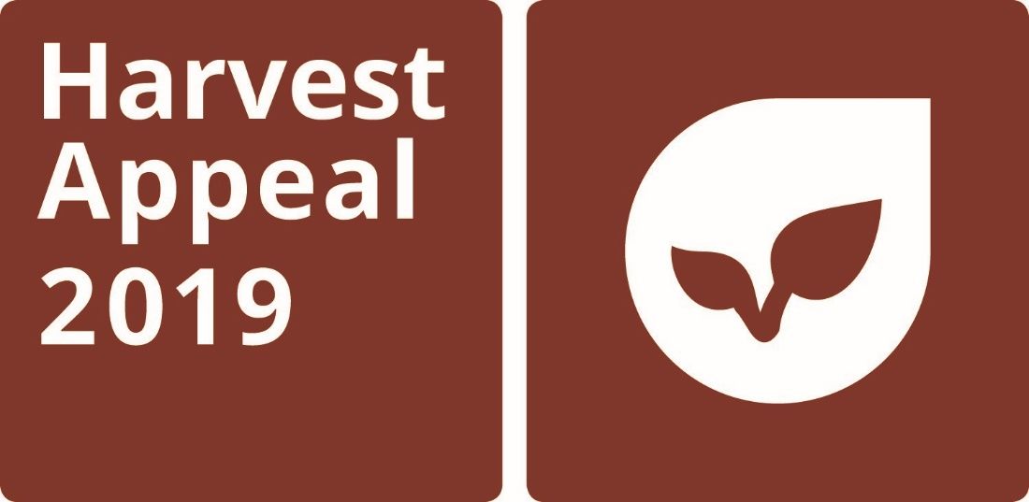

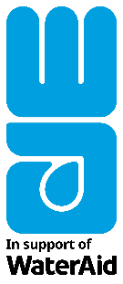
This harvest we are coming together to <share a harvest supper> and raise funds for WaterAid, so that other communities around the world will have harvests to celebrate too.
By joining WaterAid’s 2019 Harvest Appeal, we’re making sure many more communities like Ivy’s in Milimo, Zambia, will be able to celebrate bountiful harvests and a flourishing community.
Milimo used to suffer long, dry seasons of failing crops, sickness and hunger until WaterAid installed a borehole in the village two years ago. The borehole inspired the village to start a community garden where they collectively grow vegetables.
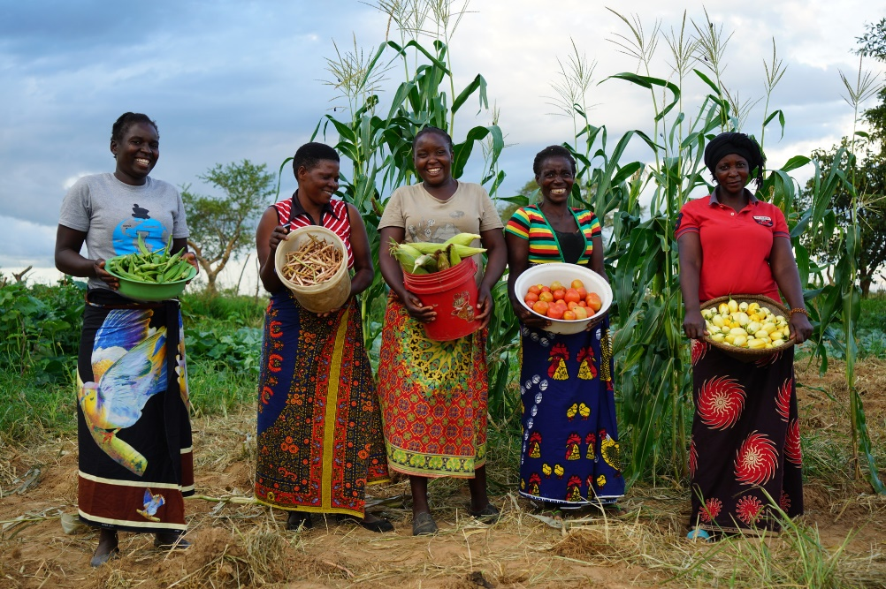
The community of Milimo can now grow enough food to eat. They are healthier and financially secure too.
Ivy says: “As a community we no longer worry about water. Our children are healthier and are going to school. We are growing lots of vegetables, some of which we sell. Life has changed greatly.”

The funds we raise for WaterAid this harvest will help transform other communities like Milimo with clean water.
Please join our <harvest supper> on <date>.
For more information on WaterAid’s 2019 Harvest Appeal please visit www.wateraid.org/uk/harvest

