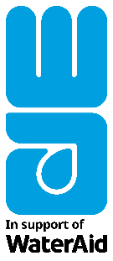
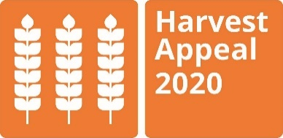

This harvest we are standing together with WaterAid so that other communities around the world can stay safe, healthy and will have plentiful harvests to celebrate.
By joining WaterAid’s 2020 Harvest Appeal we’re helping to bring clean water to communities like Felisberta’s in Timor Leste.
Families like Felisberta’s need to make long and exhausting walks to collect water and the water they can get is neither safe, nor enough for the family. The community is dependent on farming, yet without access to water they can’t grow enough vegetables to eat and sell and can’t look after their livestock.
By joining the 2020 Harvest Appeal, we’re making sure families like Felisberta’s will have clean water to drink and wash with and will have enough food, so that they can stay strong and protect themselves from disease.
WaterAid/ Vlad Sokhin

Please join our <harvest event> on <date>.

For more information on WaterAid’s 2020 Harvest Appeal please visit www.wateraid.org/uk/harvest

