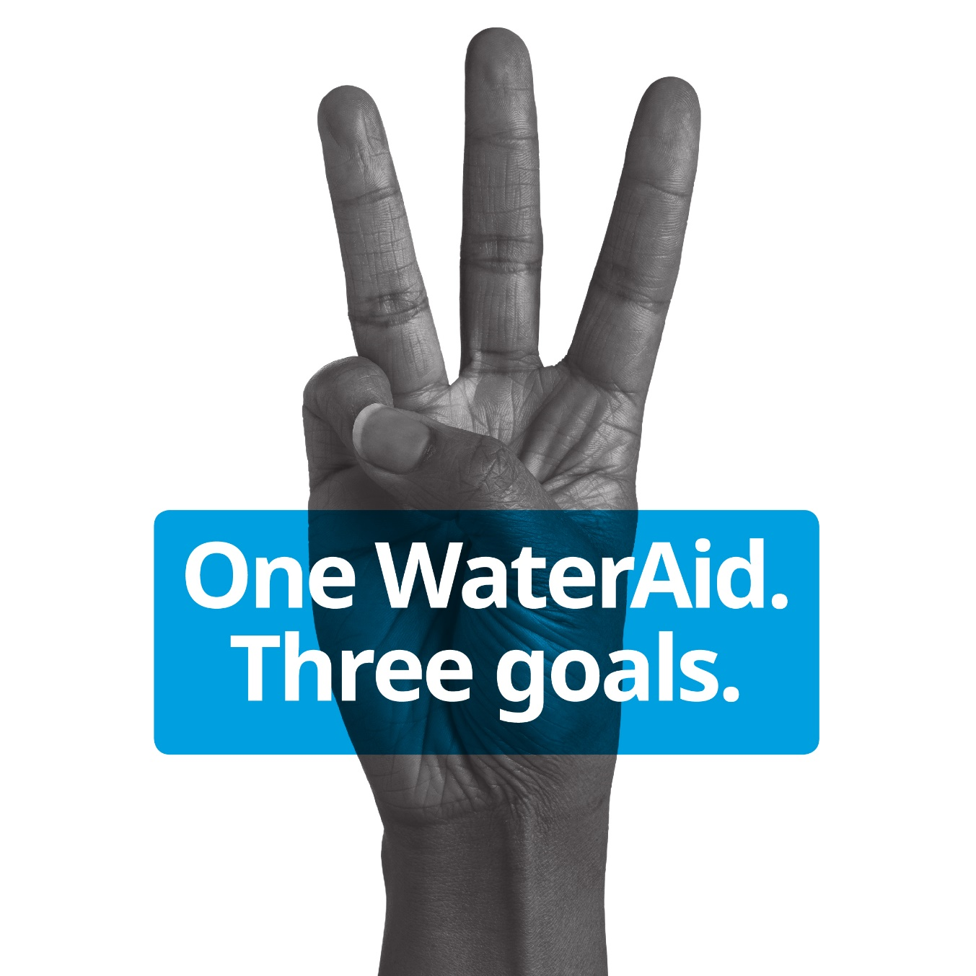
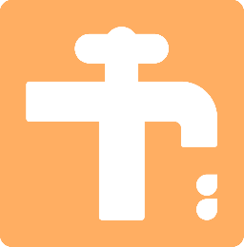
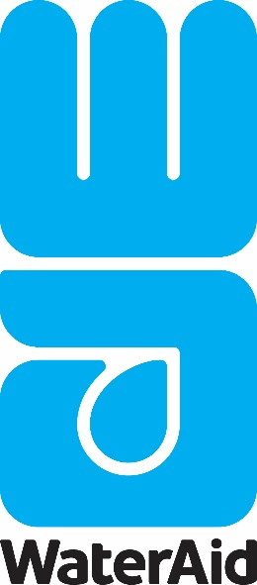
Global Code of Conduct

Global Code of Conduct

Document control
Document title: Global Code of Conduct
Scope: Global for all WaterAid members
Version: 2 |  |  | Author(s): Rachel Westcott, Director of People and Organisational Development, People Team and Leigh Heale, Global Safeguarding Manager, People Team
Date approved: December 2019 |  |  | Document status: Final
Effective date: December 2019 |  |  | Approved by: WaterAid international
Superseded version: Global Code of Conduct version 1 |  |  | Date of next review: August 2021

Version control
Date | Version | Reason for change |  | Author
16 August 2018 | 1 | Approved by boards |  | Rachel Westcott
06 June 2019 | 2 | Review approved by boards |  | Leigh Heale

Global Code of Conduct
- Introduction
  - At WaterAid, everything we do is guided by our values:
Respect
We treat everyone with dignity and respect and champion the rights and contribution of all to achieve a fairer world.
Accountability
We are accountable to those whose lives we hope to see transformed, to those we work with and to those who support us.
Courage
We are bold and inspiring in our actions and words, and uncompromising in our determination to pursue our mission.
Collaboration
We work with others to maximise our impact, respecting diversity and difference in the pursuit of common goals.
Innovation
We are creative and agile, always learning, and prepared to take risks to accelerate change.
Integrity
We act with honesty and conviction and our actions are consistent with openness, equality and human rights.

  - Working on behalf of WaterAid often means holding a position of power and trust. Those representing WaterAid are expected to always be aware of the responsibility that comes with this and never misuse it.
  - This Code of Conduct outlines what is expected of everyone who represents or works on behalf of WaterAid.
  - Terminology used in this Code of Conduct is defined in the Definitions of Safeguarding document, please see www.wateraid.org/uk/safeguarding-at-wateraid
- Scope and responsibilities
  - The commitments in this Code of Conduct apply to everyone representing or working on behalf of WaterAid. This includes staff, volunteers, trustees and consultants across all WaterAid member countries and country programmes globally.
  - Everyone representing or working on behalf of WaterAid has a responsibility to uphold the Code of Conduct at all times during their employment or engagement with WaterAid. Failure to do so may result in grounds for termination of employment or engagement or prevent future employment or engagement with WaterAid.
  - Everyone representing or working on behalf of WaterAid has a responsibility to report any concerns in relation to the Code of Conduct immediately, in line with the Reporting Malpractice and breaches to the Global Code of Conduct, which can be found at www.wateraid.org/uk/safeguarding-at-wateraid. Failure to do so could place individuals at increased risk of harm and would be considered a breach of the Code of Conduct.
- What WaterAid expects
As a WaterAid representative:

  - I will ensure my professional and personal conduct is consistent with the organisation’s values and standards. I will:
- Seek to protect public confidence in WaterAid. I will be accountable for my actions and manage any power and trust that may come with my position with restraint.
  - Respect local customs and culture, unless they contradict this Code of Conduct. I will seek advice from my line manager or other appropriate member of staff (or primary WaterAid contact if I am not employed by WaterAid) before taking any action I am not sure about.
  - Observe laws relevant to the context I am working in and comply with WaterAid’s policies.
  - Help prevent and report any criminal or unethical activities that may impact WaterAid’s work.
  - Inform WaterAid of any relevant criminal convictions I have had before my employment with WaterAid (or engagement as a volunteer or consultant) in which WaterAid may have a legitimate interest. I will notify WaterAid if I face any criminal charges during my employment or engagement that may affect my ability to carry out my duties.
  - I will treat everyone with respect and dignity and challenge harassment, bullying, discrimination, exploitation or abuse. I will:
- Not abuse any privileged position I may have in relation to the communities, partners and others I work with.
- Respect everyone’s human rights, including those who may be more vulnerable, such as children and vulnerable adults, and ensure my relationships are not abusive, exploitative or corrupt.
- Ensure I have read and comply with the provisions of WaterAid’s Global Standard on Child Safeguarding and Ethical Imagery Policy. These can be found at www.wateraid.org/uk/safeguarding-at-wateraid
- Not have sexual relations at any time with children (defined as a person under 18 years of age), vulnerable adults or members of the communities I work with (in exchange for assistance or for any other reason).
- Ensure I do not, at any time, exchange money, offers of employment, employment, goods or services for sex or sexual favours, or take part in any form of humiliating, degrading or exploitative behaviour. I understand this standard exists to challenge sexually exploitative and abusive behaviour.
- Contribute to a working environment characterised by mutual respect, integrity and dignity. I will positively encourage diversity and demonstrate respect for people who have different backgrounds, beliefs, customs, traditions and ways of life e.g. race, colour, gender, language, religion, political or other opinion, national or social origin, property, birth or other status such as disability, age, marital and family status, sexual orientation and gender identity, health status, place of residence, economic and social situation.
- Ensure the dignity and respect of colleagues and others I interact with, by refraining from inappropriate behaviour, discrimination, bullying and harassment. I understand these types of behaviours are not only unacceptable on moral grounds, but harm morale, performance, attendance and retention.
- Be courteous and professional in my dealings with colleagues and others and not use inappropriate or offensive language, either verbally or in writing.
  - I will avoid any possible conflicts of interest between my private life and WaterAid’s work. I will:
- Declare any interest (financial or otherwise) in WaterAid’s work where I have an influence on a decision being made (e.g. a contract for goods/services, employment or promotion within WaterAid, a partner organisation or community group). I will not abuse my position to secure benefits for myself or any family member or friend.
- Not commit to or carry out any employment, consultancy work, trustee/director role, voluntary role or political activity, or take a business interest in a supplier where a conflict of interest arises. This includes activities that may bring WaterAid into disrepute or could affect my ability to conduct my role appropriately. If in doubt, I will seek advice from my line manager (or primary WaterAid contact if I am not employed by WaterAid). Where potential conflicts can be mitigated, I will agree appropriate mitigation measures with my manager.
- Report any form of corruption or other contravention of this section 3.3, that I become aware of, or should have become aware of that directly or indirectly impacts WaterAid’s work.
- Not offer, promise, give or accept bribes.
- Not accept any gift, gratuity or incentive that could be seen as payment for giving favour or advantage. I will reject monetary gifts or inappropriate gifts offered to me as a result of my employment or engagement with WaterAid from governments, the communities I work with, donors, suppliers and others. Where giving and accepting gifts is normal cultural practice, I will ensure these are only small tokens of appreciation, with little monetary value, and will report them to my line manager (or primary WaterAid contact if I am not employed by WaterAid).
- Report any attempts at bribery, in relation to my work at WaterAid, immediately to my line manager (or primary WaterAid contact if I am not employed by WaterAid).
- Seek appropriate authorisation before communicating externally in WaterAid’s name, unless prior agreement is in place due to the nature of my role or engagement with WaterAid. I will not express views or opinions publicly or on social media that could damage WaterAid’s reputation by contradicting its ethos, values or policies.
  - I will act responsibly with the resources, money, equipment and information I have access to through my work with WaterAid. I will:
- Use all WaterAid resources responsibly and account for any money, information and equipment entrusted to me (e.g. vehicles, accommodation, office equipment, computers, the use of internet and email).
- Not commit any financial impropriety including fraud, bribery, corruption or money laundering.
- Use WaterAid’s IT and communications equipment appropriately and comply with local IT policies. I will not view, download, create or distribute inappropriate or offensive materials, including, but not limited to, pornography.
- Comply with global and national requirements on the use and protection of data and information. I will not disclose personal or confidential data or information to people who should not have access to it, or misuse it in any way.
- Consider my impact on the environment and use resources as sustainably as possible.
- Report any misuse of funds and/or assets as soon as I suspect it, to ensure WaterAid can protect its assets and resources.
  - I will ensure my actions do not create an unacceptable risk to anyone’s health, welfare, safety or security. I will:
- Comply with all local security and health and safety management policies, plans and guidelines.
- Avoid any unnecessary and unacceptable risk to my health, welfare and safety and that of others, including partner organisations and members of the communities I work with.
- Carry out appropriate risk assessments and act on the outcomes. I will inform my line manager (or primary WaterAid contact if I am not employed by WaterAid) if there is a safety or security risk to be addressed.
- Not work under the influence of alcohol, unless during special circumstances agreed by management (e.g. an event outside of working hours, where I will ensure I am still able to do my job and represent WaterAid appropriately).
- Not work under the influence of any illegal drug or illegal drug-related substances or use or be in possession of these on WaterAid premises, vehicles or accommodation.
- Declaration
In accepting my role representing or working on behalf of WaterAid, I will carry out my duties and behave in accordance with this Code of Conduct, contributing to WaterAid’s performance, reputation and success. If I am unclear about any areas of this Code of Conduct, I will discuss them with my line manager (or primary WaterAid contact if I am not employed by WaterAid). I am aware I am obligated to report incidents of malpractice or breaches of conduct to my line manager or through the reporting channels outlined in the Global procedure for reporting malpractice and breaches to the Global Code of Conduct, which can be found at www.wateraid.org/uk/safeguarding-at-wateraid
Name: ______________________________________________________________________________________
Signature: ______________________________________________________________________________________
Date: ______________________________________________________________________________________

