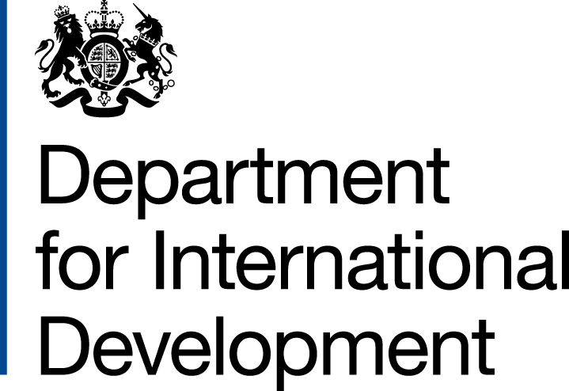

Partner use of the UK aid logo in UK Aid Match funded appeals

The UK aid logo has recently been updated. Partner organisations that receive UK aid funding from DFID will be familiar with using the UK aid logo to show the British public where their taxes, through DFID, are being spent.

1. Logo variation: There is a variation of the new logo for use in UK Aid Match communications. UK Aid Match partners must use this version of the general UK aid logo, in their communications both during their appeal and when reporting back on what the extra funding has achieved. We would expect to see the logo appear on the organisation’s homepage, donation page, and on most communications relating to the appeal.
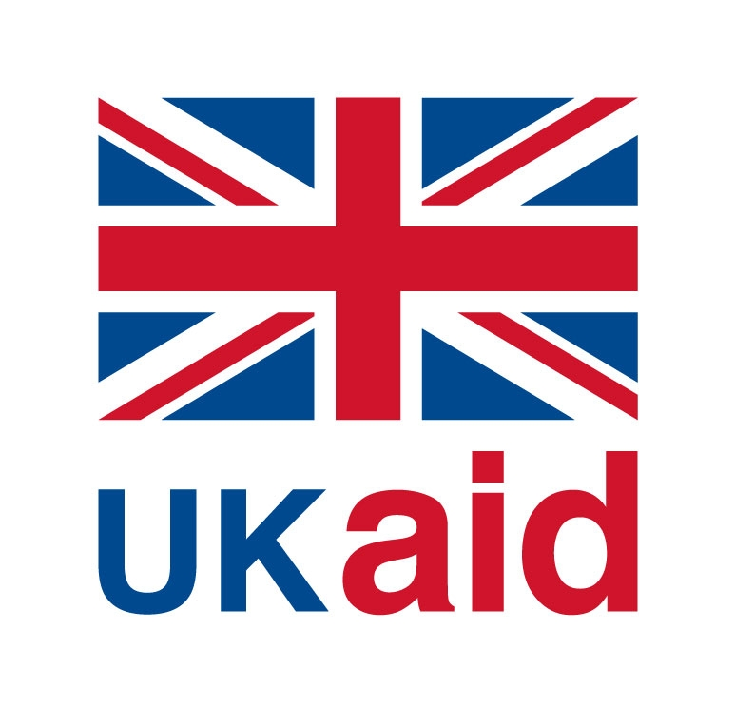
Logo for UK Aid Match partners to use

2. Prefix: When using this logo, partners should where appropriate, prefix the logo with the phrase ‘Matching your donations with’ in an appropriately sized and coloured font. The prefix may encroach slightly upon the logo’s exclusion zone (width of the ‘U’). The minimum size is 17mm in width

If you wish the font colour to match the new UK aid blue, the specifications are Royal Blue PANTONE® 280 C, C:100 M:72 Y:0 K:19; R:0 G:36 B:125; Hex: #CF142B].

For example:
Matching your donations with
The other instructions for use in the general UK aid guidance for partners also apply.

NB: This version of the logo is ONLY for use in your communications that relate to your appeal and reporting back under the UK Aid Match scheme. Use the general UK aid logo (‘from the British people’) on communications that relate to all other DFID funding schemes.

For any questions on the use of the logo and for logo files, please contact: corporatecommunications@dfid.gov.uk

