World Toilet Day
19 November 2013

Below you’ll find stories from some of WaterAid’s sanitation projects. Full size images to accompany each story can be found here.
Before using any of the images please read our photo Terms and Conditions. And please make sure all images are credited every time they are used. You’ll find the credit next to each thumbnail below, it should be written as ‘WaterAid/Photographer’s Name’.

Kalshi Takar Baa slum, Mirpur area, Dhaka, Bangladesh
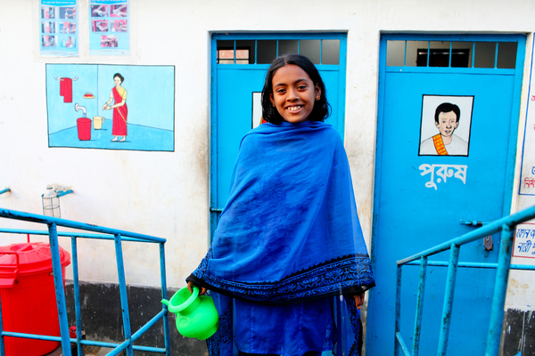
Image: BG24_0846
Title: Lima, aged 12, outside a latrine block
Credit: WaterAid/GMB Akash/Panos
The Kalshi Takar Baa slum is almost an island, with only one entrance point and surrounded on all sides by water. 1,700 households live on ten acres of land and, until recently, there were no toilets.
Now there are 20-30 small toilet blocks with one latrine for every ten families. Some of the toilets have been adapted so pregnant women and elderly members of the community find them easier to use. There is also a water supply in each toilet for hand washing and cleaning.
Families in the community take it in turns to clean the toilet blocks, making sure they are cleaned every day. They have also formed a hygiene committee to promote hand washing and sanitation messages.
The committee responsible for building the toilets has noticed fewer people are suffering from diarrhoea and cholera since the toilets were built: “I know all these diseases are related to water and sanitation. Before we were sick a lot. Sometimes four or five people would be in hospital at a time and would have to pay a lot. Some people died. Now people get sick less frequently and have more money."”

Jogidanda village, Bahuntilpung VDC, Sindhuli district, Nepal
Image: NP33_312
Title: Naranda and Yashoda Shrestha on the site where they are building a latrine
Credit: WaterAid/Tom Van Cakenberghe
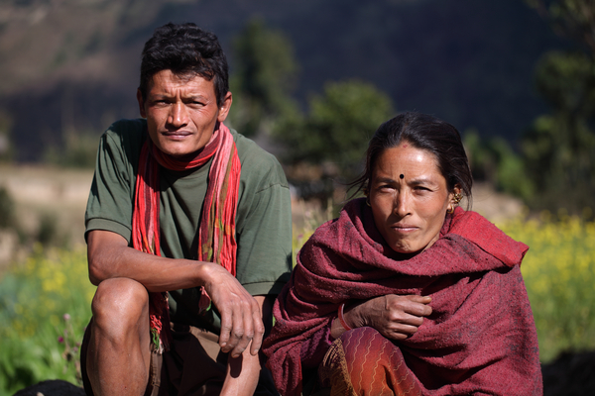
Naranda and her husband Yashoda live in the Sindhuli district of Nepal. They are building their own latrine as part of a project to provide every house in the area with a toilet.
Before the project, the district was ranked as one of the worst in Nepal for access to water and sanitation. Naranda is very happy the toilet is being built: “For the last five or six months we have been using a temporary latrine. Before that we had to go on stones, and there was the risk of being seen on open ground. It was shameful.
“We hope there will be a lot of changes after the toilet has been constructed. It will be cleaner and will look good. The temporary latrine has a bad smell but we hope this problem will be solved.”

Nsasa, Mpigi, Kammengo, Uganda
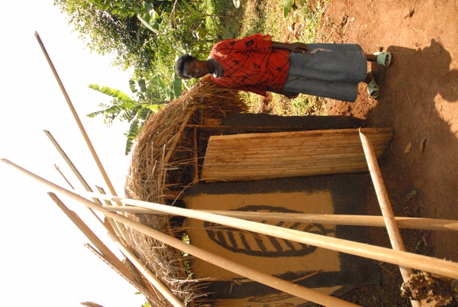
Image: UG49_085
Title: Sarah in front of her latrine
Credit: WaterAid/Caroline Irby
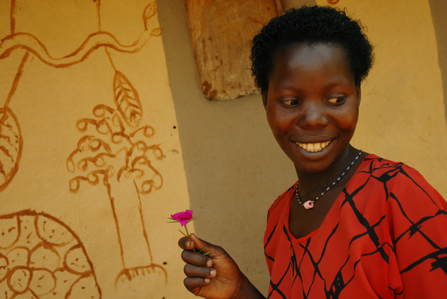
Image: UG49_093
Title: Sarah at her house
Credit: WaterAid/Caroline Irby
Sarah is from the Nsasa community in Mpigi, Kammengo, Uganda. Before she had a latrine she had to go to the toilet in the bushes. “It was not comfortable to go to the toilet there because there was no privacy. I was always looking around for snakes or people watching.
“Many people used to go to the toilet in the bush and when it would rain I would get hookworms from walking in the grass. I would have to take time to clean my legs thoroughly because I feared we may have picked up worms from the faeces on the grass.”
Latrines constructed from locally available materials such as mud, wood and reeds mean Sarah and her family now have somewhere sheltered to go the toilet. These new latrines, and a hygiene education programme promoting the benefits of hand washing, have cut the incidence of diseases in her community.

Kebele 6 Health Post, Addis Ababa, Ethiopia
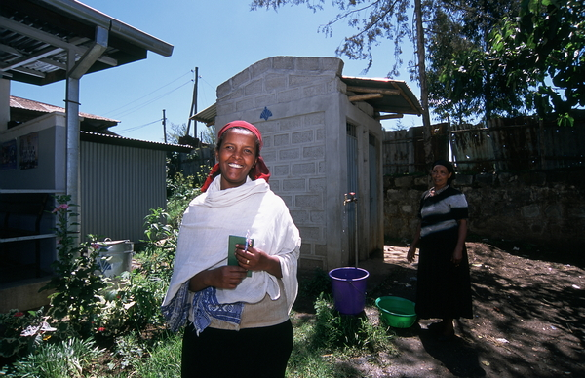
Image: ET22_018
Title: Zenebech Zewede at a latrine block and water tap
Credit: WaterAid/Caroline Irby
A recent sanitation project at Kebele 6 health post in Addis Ababa has brought ventilated improved pit (VIP) latrines, public showers and water distribution points to people living in the neighbourhood.
Zenebech Zewede has been involved in the project since it started, she says: “Before, when I needed the latrine I used to have to go in the neighbourhood. Now I can have a shower, use the latrines, get water and wash my clothes freely. It is a big gift to be clean.”
Aba Roba, Konso, Ethiopia
Image: ET33_618
Title: Children from the village in front of the recently built pit latrine
Credit: WaterAid/ Anna Kari
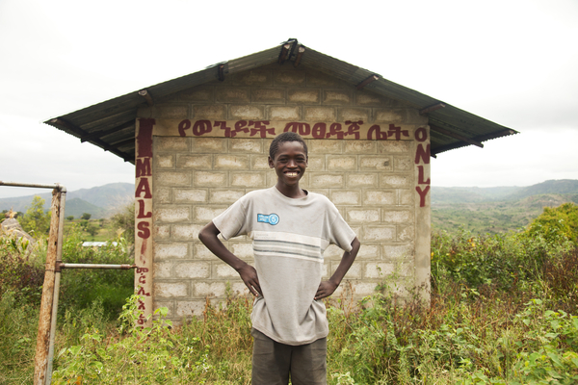
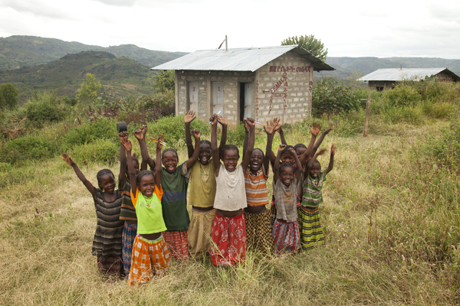
Image: ET33_752
Title: Mohammed,12 years, in front of the pit latrine toilets
Credit: WaterAid/ Anna Kari
Foro is a sub-village of Aba Roba, a remote area in the hilly terrain of the Konso region. There are 1,442 households in Aba Roba and 11 sub-villages.
Because the terrain is so challenging, efforts to install water sources in the past have been temporary, often drying up after a year or so. Ten years ago the local government started encouraging families to build latrines but many of these fell into disrepair.
Now everyone in Foro has a household latrine and the primary school has its own toilet blocks. These include two specially designed toilets for children with disabilities.
A hygiene education programme has been in place for three years, including a WASH (water and sanitation hygiene) club in the school for children up to Grade 4. The village is incredibly proud of their improved hygiene practices.

Chiobola school, Nyimba ward, Zambia
Image: ZAM7_159
Title: Junior Elinah Mazuba stands outside the school latrines
Credit: WaterAid/ Anna Kari
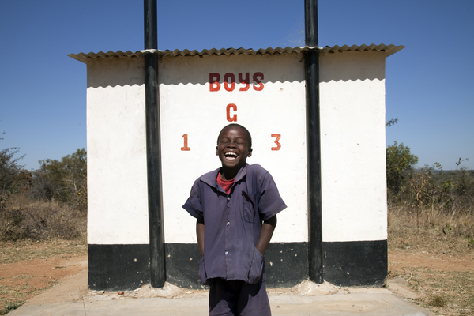
Image: ZAM7_161
Title: Junior Elinah Mazuba and Michek Chooka by the school latrines
Credit: WaterAid/ Anna Kari
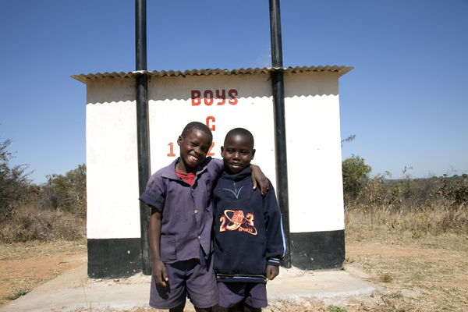
Junior Elinah Mazuba is nine years old. He is really proud of the toilets at his school: “I like these toilets, they are beautiful! Because they have pipes! And they remove dirt and smell. I like school, in the future I want to teach mathematics, it is my favourite subject.”
WaterAid started work in the area in 2008 and has built eight toilet blocks with ventilated improved pit latrines for students at the Chiobola school. There are separate toilets for girls and boys and outside each block is a hand washing facility.
“We clean the toilets after we use it to remove all the dirt. We learned this and to wash our hands at school. I have two sisters and four brothers and we tell our brothers and sisters to wash their hands too.”

Yapalsi, Tamale, Northern Region, Ghana
Image: GH26_585
Title: Sulemana Isa building a new latrine
Credit: WaterAid/ Jon Spaull
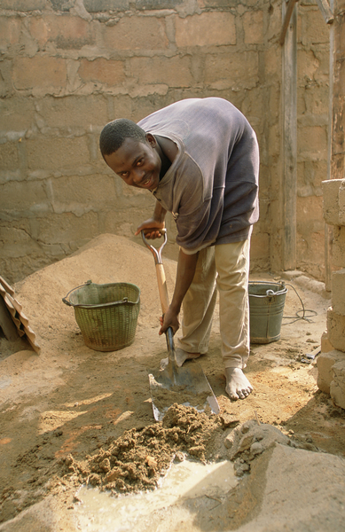
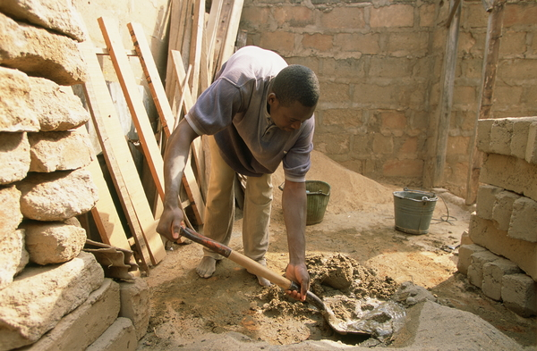
Image: GH26_584
Title: Sulemana Isa building a new latrine
Credit: WaterAid/ Jon Spaull
Sulemana Isa is 24, he lives in Yapalsi an area in the northern region of Ghana where WaterAid and New Energy are helping communities to build their own household ventilated improved pit latrines.
“I live in this house and I am helping with the latrine construction. I helped to dig the pit, mould the blocks and carry them here. Now I am mixing the mortar. I also bring the water for construction from behind the house. We expect to finish both pits in two days.
“We used to go to the toilet far away in the bush. It was a real problem and in the rainy season it was very muddy and there were snakes. Having a latrine in the house will improve sanitation around our home and make a real difference. When I have finished the latrine for our house I will be happy to help other households to build theirs.”
Five people are employed as permanent latrine builders and nine new builders are being trained so they can make a living from building and can pass on their skills to other people in the community.

WaterAid transforms lives by improving access
to safe water, hygiene and sanitation in the world’s
poorest communities. We work with local partners
and influence decision-makers to maximise our impact.

WaterAid
47-49 Durham Street
London SE11 5JD
Tel: +44 (0) 845 6000 433
www.wateraid.org

Registered charity numbers 288701 (England and Wales) and SC039479 (Scotland)

