You can include this text and picture in your church newsletter, magazine or read it during your notices to let your congregation know about WaterAid’s Harvest Appeal. We have also included a photo and logos to use too.
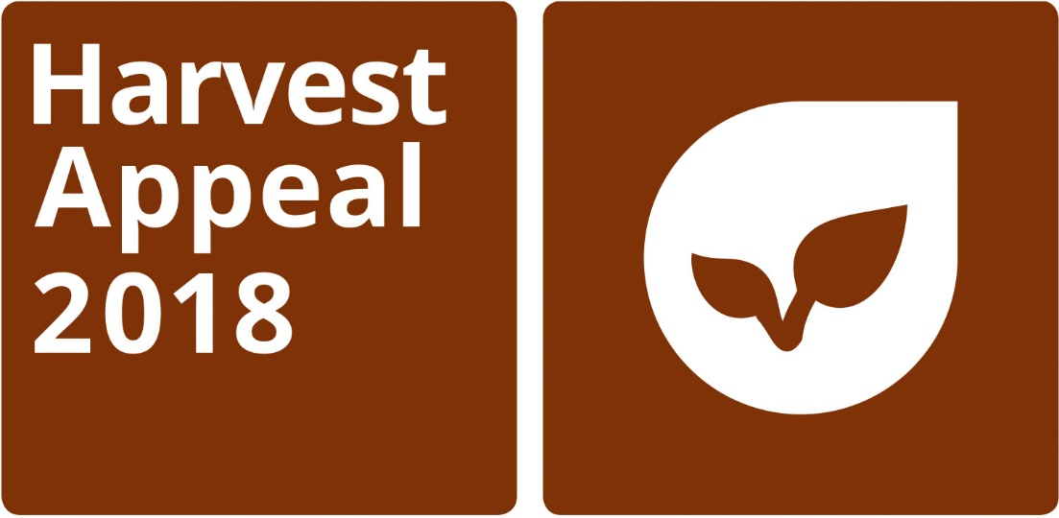

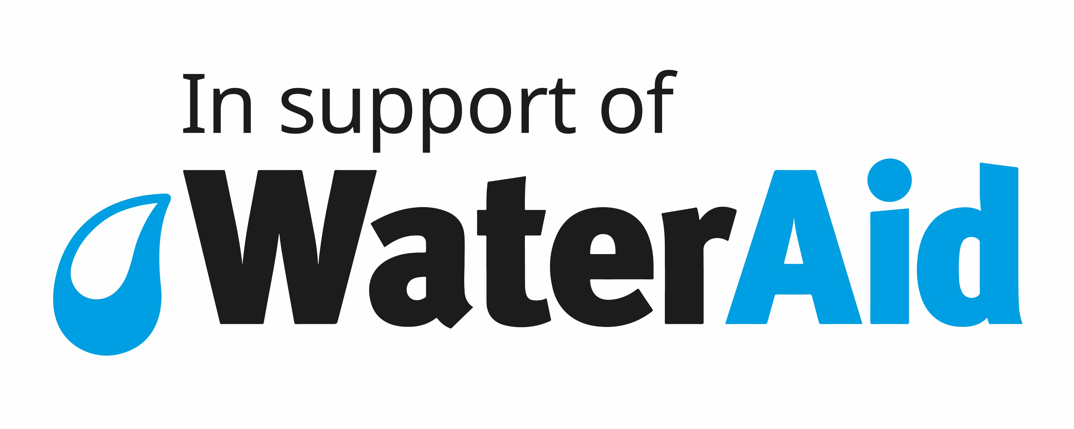
This harvest our congregation is making sure communities across the world have a harvest worth celebrating.
We will be joining together on <insert date> at <insert time> to share a harvest supper and raise funds for WaterAid. The money we raise will mean families around the world get access to clean water which they can use to grow healthy, nutritious food.
Families like Evelyne’s in Sablogo, Burkina Faso. Before WaterAid installed a borehole in Sablogo, providing clean water for the whole community, they were forced to dig into a nearby riverbed to collect water from the sand. This water was dirty and unreliable which made growing crops hard and meant Evelyne’s children suffered from stomach aches, sickness and diarrhoea. However, with the arrival of clean water, those illnesses are a thing of the past, and Evelyne’s children are well enough to go to school.
Evelyne says, ‘Water and food go together. Our harvest and food - we have them thanks to water. The quality of our meals also depends on the water that we use for cooking.’
This harvest, we will make sure that WaterAid can reach even more families like Evelyne’s and bring life-changing clean water. Please see <insert name> if you have any questions about our harvest supper. Or if you would like more information about WaterAid’s Harvest Appeal visit: www.wateraid.org/uk/harvest.
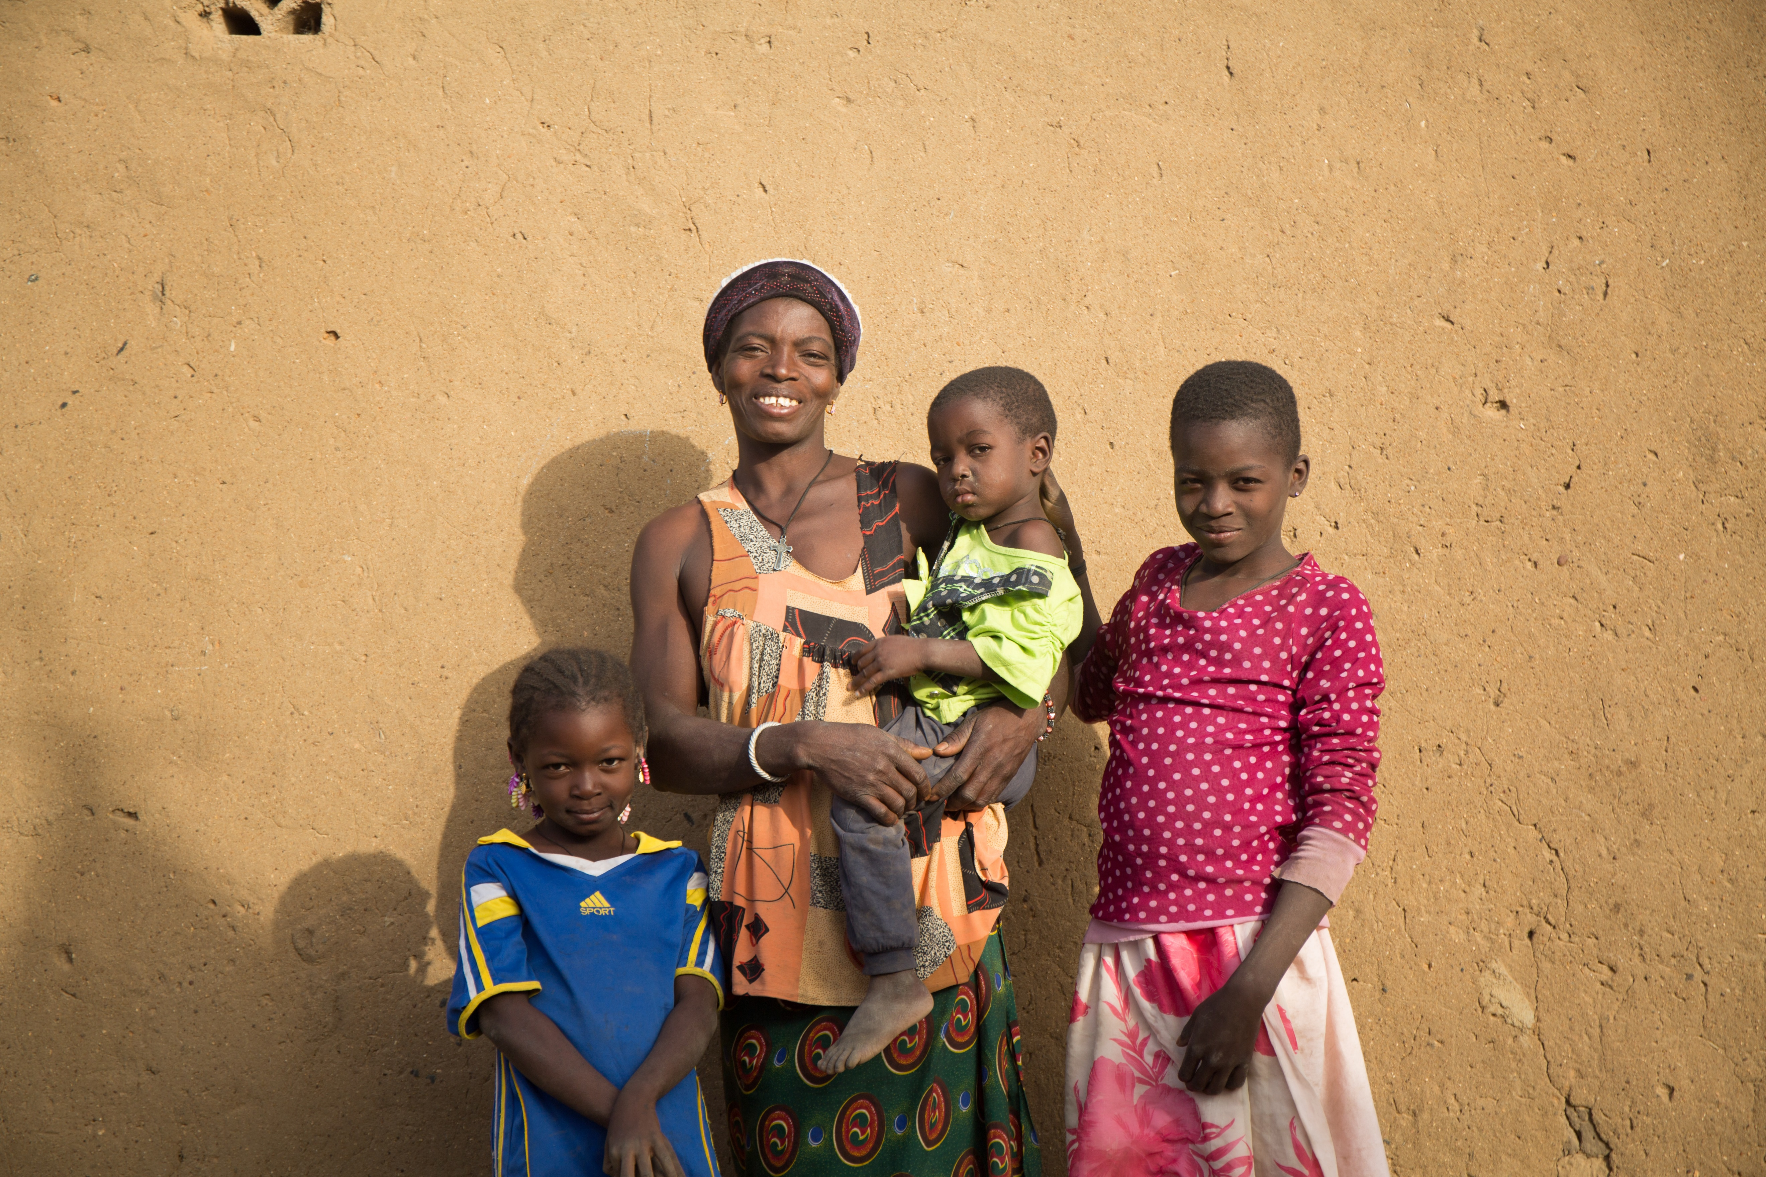
Evelyne and her family in Sablogo, Burkina Faso. Credit: WaterAid/ Basile Ouedraogo

